**02 - Enthalpy splitting test**

Results with 2D TGV at 20x20 nodes.

1. **Reference schemes**

KGP, F and C convective schemes have been compared showing no differences in 2D TGV Standard initial conditions at 0.1s.

1. **Enthalpy split**

Energy equation inviscid part was done with enthalpy considering both convective and pressure gradient term. This was compared back to back to “reference case” with energy equation separated from the pressure gradient and results showed good agreement in terms of both velocities and energies.

Assuming that E is the total energy per unit mass (we transport rho*E, energy per unit volume), and the pressure p has the dimensions of energy per unit volume, then the 'enthalpy splitting' should be applied to the triple product rho*u*h where h = E + p/rho is the enthalpy per unit mass.

(d (rho uj E) / dxj) + ( d (p uj) / dxj) = **d (uj *· rho/ rho ·* (rho E + p) ) / dxj )** = **d (uj (E + p/rho) ) / dxj )**. Hence **E + p/rho = h** total enthalpy per unit mass.

Results (slice at xz and yz planes):

- Sweep in X direction at y = 5/20*Ly (Position 5 out of 20 inner nodes)

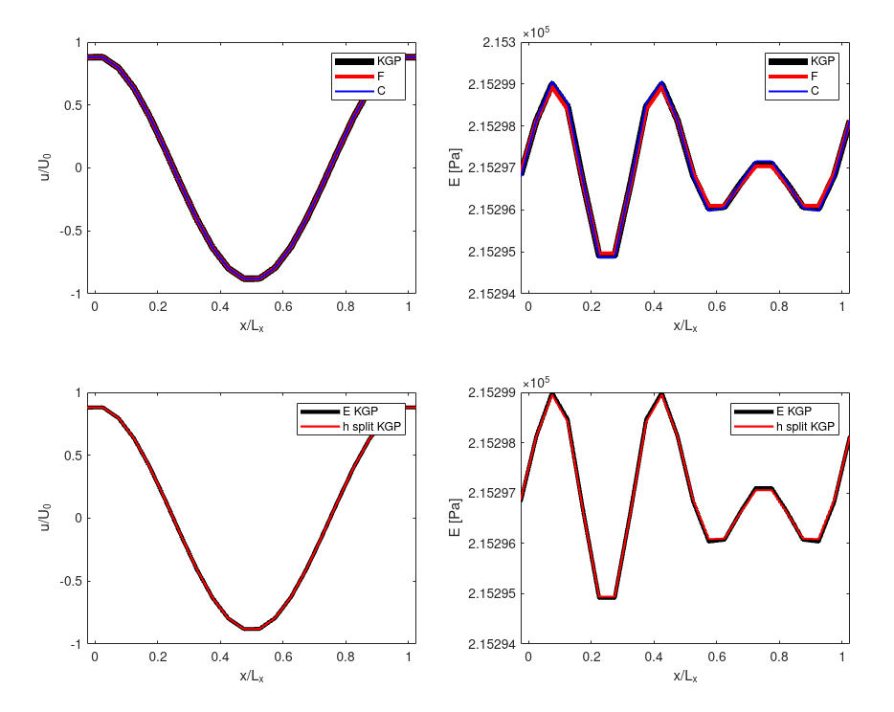

* Sweep in X direction at y = 10/20*Ly

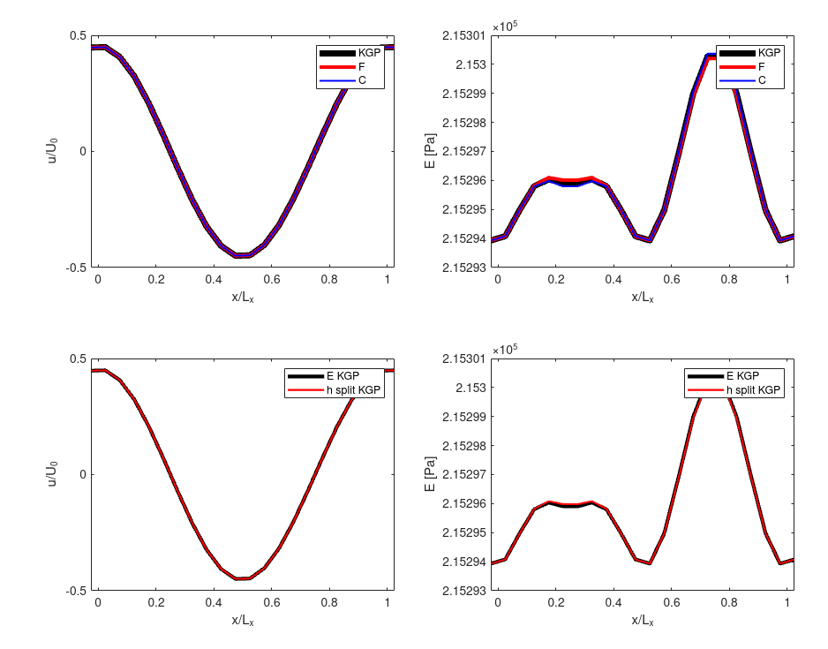

* Sweep in Y direction at x = 5/20*Lx

